**10.5 ADMINISTRATIVE AMENDMENT TO MLEP 2009 - 3 RACECOURSE ROAD, MUSWELLBROOK**

**Attachments:** **a. Planning Proposal - 3 Racecourse Road Muswellbrook**

**b. 8 October 2020 Council letter regarding the dwelling entitlement status of the land**

**c. Denman Shire Council agenda and minutes**

**d. Request to prepare Planning Proposal Submitted by the applicant**

**Responsible Officer:** **Fiona Plesman - General Manager**

**Author:** **Sharon Pope - Executive Manager - Environmental and Planning Services**

***Community Plan Issue: Diversify the economy, facilitate the development of intensive agricultur and other growth industries, make the Shire a more attractive place to invest and do business***

***Community Plan Goal: Review the Local Environmental Plan and Development Control Plan to improve investment certainty for industry.***

***Community Plan Strategy: Progress completion of an LEP and DCP.***

**Purpose**

Council has received a request to amend the Muswellbrook Local Environmental (MLEP) 2009 in relation to 3 Racecourse Road Muswellbrook (Lot 41 DP 592207). The request seeks to allow the erection of a dwelling.

Council is the Planning Proposal Authority for amendments to the MLEP 2009. The purpose of this report is to assess the applicants request to amend the MLEP 2009 and determine whether to prepare a planning proposal and progress the matter in accordance with the requirements of the *Environmental Planning and Assessment Act 1979.*

*Do not delete this line*

|  |
| --- |
| **Officer’s Recommendation**   1. Council resolves to prepare a Planning Proposal to amend the Muswellbrook LEP 2009 to permit a dwelling house on 3 Racecourse Road Muswellbrook (Lot 41 DP 592207), in accordance with the draft Planning Proposal provided in Attachment A. 2. Council write to the Department of Planning, Industry and Environment requesting a Gateway Determination to the Planning Proposal and request the Department authorise Council to exercise the plan making powers delegated to it by the Department in relation to this matter. 3. Council delegate to the General Manager, the completion of any required public or agency consultation and the making of amendments to the planning proposal required as an outcome of the Department of Planning, Industry and Environment’s Gateway Determination. 4. That following the completion of any public and agency consultation required by the Gateway Determination, where Council receives no submissions objecting to the proposal, delegate to the General Manager the authority to exercise Council’s plan making powers to make the requested amendment to the Muswellbrook LEP 2009. |

*Do not delete this line*

**Moved: _____________________________ Seconded: _______________________________**

**BACKGROUND**

Lot 41 DP 592207 is zoned RU1 Primary Production under the MLEP 2009 and has an area of 6.07ha. There are existing sheds, stables and day yards constructed on the land, and the remaining area is pasture improved and divided into paddocks. The site is currently vacant, but the owner intends to establish a racehorse training facility on the property and has identified the need for someone to live on site to:

* monitor horses, and
* complete regular feeding, training and health care regimes.

In response to an enquiry, Council Officers provided a letter on 8 October 2019 advising that the lot is not benefited by a ‘dwelling entitlement’ under the provisions of Clause 7.5 of the MLEP 2009. This correspondence is provided in Attachment B for Council’s information.

Staff undertook extensive research on the history of the lot. The Business Paper and Meeting Minutes of the 12 April 1977 Denman Ordinary Council Meeting refer to an application for the subdivision which created the lot. The Business Paper included a reference to use of each proposed lot in the subdivision being *‘for agricultural purposes in conjunction with a dwelling house’.* The business paper and meeting minutes are included as Attachment C.

Despite the subdivision proceeding, no dwelling house was constructed on Lot 41. Changes to planning legislation since 1977 has had the result of extinguishing any ‘dwelling entitlement’ for the land in place in 1977 and the period immediately following its subdivision.

MLEP 2009 would need to be amended to reinstate a dwelling entitlement for this lot. The preparation of a Planning Proposal is the first step in the process of amending a Local Environmental Plan. Council has received a request to amend the MLEP 2009 to allow the erection of a dwelling (see Attachment D).

**CONSIDERATION OF A PLANNING PROPOSAL**

In considering whether to endorse the applicant’s request staff have assessed to proposal with regard to strategic planning frameworks, constraints affecting the land and its suitability for development, and the case specific merit applying to this lot.

Strategic planning framework

This proposal does not seek to rezone the subject land, rather, it seeks to create a dwelling entitlement for an existing Lot. This planning proposal is not directly guided or informed by a regional or local strategic planning document. The provision of rural residential lifestyle living opportunities broadly aligns with Housing and Settlement Principles outlined in the Upper Hunter Strategic Regional Land Use Plan and the Hunter Regional Plan.

While the land is zoned RU1 – the area of the lot is approximately 6ha. The land is within a precinct which surrounds the Muswellbrook Racecourse on the outskirts of the Muswellbrook township. Many of the other lots in the area are a similar size, are used for equine activities, and contain dwellings. The proposal is not inconsistent with the Primary Production and Rural Development SEPP and the NSW State Gov Right to Farm policy.

Council Officers support the planning proposal due to its relationship with its strategic planning objectives.

Site constraints and suitability for development

A rural residential pattern of development already exists in the Racecourse Road locality. There are sixteen (16) RU1 Primary Production zoned lots with frontage to Racecourse Road, with comparable lot sizes to the subject land, with dwellings. An additional fourteen (14) lots zoned RU1 Primary Production are in the wider precinct that includes Shephard Avenue. A dwelling house on Lot 41 DP 592207 would be compatible with the general rural residential living character of the area. A plan showing the locality is provided below:

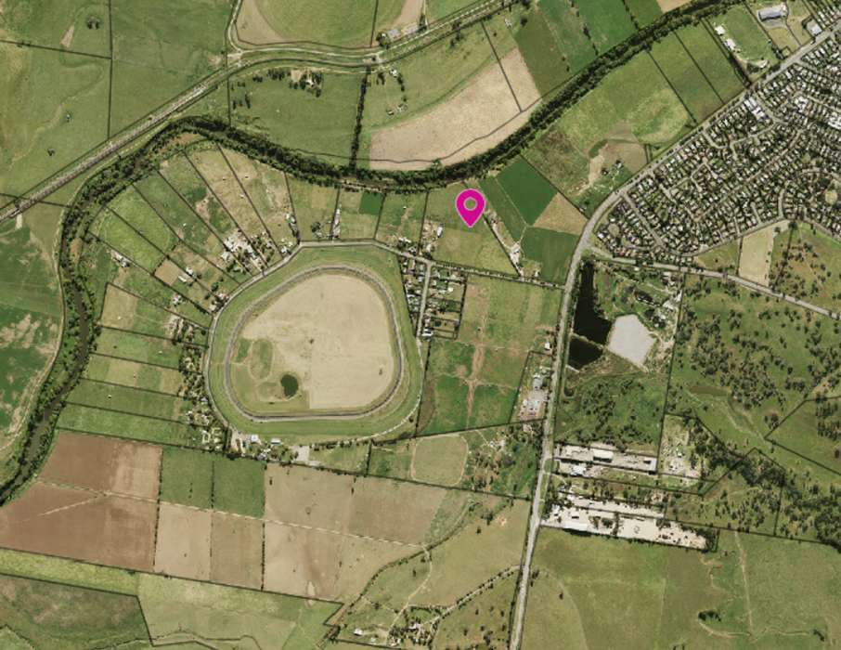

The lot is flood affected. The s9.1 Ministerial Direction - 4.1 Flood Prone Land - applies to a planning proposal that affects the zoning of flood prone land and requires planning authority to have regard to hazard related issues and adhere to the Floodplain Development Manual 2005. The applicant has suggested that this Section 9.1 Directive does not have bearing on the proposal as it does not seek the rezoning of the land and has indicated that any dwelling would need to be constructed above the flood planning level in accordance with standard Council requirements.

The erection of a dwelling on the allotment:

1. would not be within a floodway
2. will not result in significant flood impacts to other properties
3. will not represent a significant increase in development on the locality

Any future dwelling will be required to be constructed to the appropriate flood planning level. There are numerous other dwellings in the immediate vicinity of the subject allotment. The proposal is unlikely to result in a substantially increased requirement for government spending on flood mitigation measures, infrastructure or services.

To ensure there is no inconsistency with the Ministerial Direction, consultation with SES should occur during the notification of the Proposal.

Additional merit considerations

The Meeting Minutes of the 12 April 1977 Denman Ordinary Council Meeting suggest that at the time of subdivision the erection of a dwelling would have been permissible.

As a result of legislative changes following the creation of the lot, the land is not considered to have a ‘dwelling entitlement’ under the provisions of the Muswellbrook LEP 2009. Council Officers are not aware of any evidence that suggests Council, or a relevant Government Department undertook these legislative changes with the deliberate intent to limit the opportunity for a dwelling on the land.

**CONSULTATION**

Public and agency consultation required as part of the planning proposal process is specified by the Department of Planning, Industry and Environment (DPIE) as part of the Gateway Determination. Should this matter proceed to a Gateway Determination this consultation will be carried out in accordance with any requirements of DPIE.

**CONSULTATION WITH COUNCILLOR SPOKESPERSON**

There has been no consultation with the Councillor Spokesperson in relation to this item.

**FINANCIAL IMPLICATIONS**

The applicant has paid application fees in accordance with Council’s 2019/2020 fees and charges.

**STATUTORY & POLICY IMPLICATIONS**

This item seeks to make an amendment to the MLEP 2009. The requested amendment is an Administrative Amendment. The options for amending the LEP include:

* A change to the Schedule 1 – additional Permitted Development; or
* A change to clause 7.5 of the LEP
* A change to the zoning and/or the minimum lot size map applying to the lot.

The first option is simpler as it requires minimal GIS input. Depending on the option preferred by DPIE, and timing and progression of Council’s LEP review, Council Officers may progress this planning proposal as a component of the new Shire-wide LEP.

**LEGAL IMPLICATIONS**

When a council does not support a written request to prepare a planning proposal, the council is required to notify the proponent as soon as practicable in writing that the proposal is not supported. The Proponent may they seek a review of the decisions by DPIE.

OPTIONS

Council may:

1. Resolve to prepare a Planning Proposal to amend MLEP 2009 to permit a dwelling house on Lot 41 DP 592207. This is the preferred option as the Meeting Minutes of the 12 April 1977 Denman Ordinary Council Meeting suggest that at the time of subdivision the erection of a dwelling would have been permissible, and a dwelling house is compatible with the character of the locality; or
2. Reject the Amendment request and take no further action.

**CONCLUSION**

It is recommended that Council support the applicants request to amend the MLEP 2009 and prepare a Planning Proposal for a Gateway Determination by the Department of Planning, Industry and Environment.